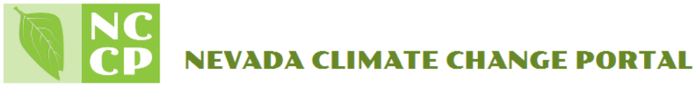
Introduction to Transect Data

What are transects and why monitor them?

Transect data research is a type of distance sampling. Distance sampling is a technique during which samples are collected on a designated transect line or points. Transect data can encompass either one or multiple variables from a monitored plot. Such data is typically monitored over a prolonged period of type and is ultimately available for comparison between multiple plots.

In order to accurately collect data, various sensor and monitoring equipment is implemented on site. Such equipment can measure change in temperature, weather, soil, surrounding plant and organism life. Depending on the course of study, equipment, plot size, location, and controls will vary. However, in general, transect data is used to study and monitor the course of long-term changes and fluctuations.

Transect sites can provide data for environmental research in the field of ecology, meteorology, climate change, etcetera.

Why sample

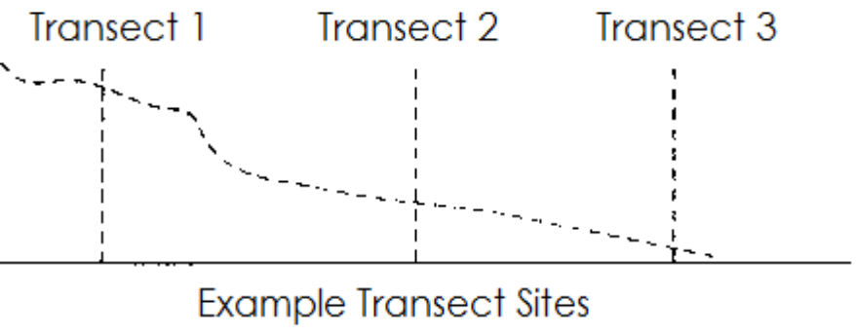
Prior to conducting a study, it is important to determine the type of data needed, the location of the sites and why. During an ecological study, it may be important to know what type of plant and animals are inhabiting a particular area. Thus, it will be important to sample the quantity of organisms, the availability of their habitat, the fluctuation of their population and other factors of interest. Ultimately, collected data can be used to evaluate and project fluctuations. Once your interest of study is established, it is important to determine what type of equipment, sensors, and monitors are required.

Possible site equipment

- Precipitation gauge - measures rain and snow at high elevations.
- Tipping bucket sensor - measures rain and snowfall under the tree canopy for comparison with inter-plant areas.
- Acoustic ultrasonic snow depth sensor - measures snow depth by using ultrasonic pulses aimed at a target such as the ground.
- Ambient air temperature thermocouple - measures air temperature.
- Radiometer sensor - measures and compares incoming and reflected infrared radiation.
- Quantum sensor - measures photosynthetically active radiation.
- Propeller anemometer - measures wind speed and direction.
- Barometer sensor - measures barometric pressure.
- Capacitative RH sensor - measures air temperature and relative humidity.
- Dual probe heat pulse (DPHP) sensor - measures soil thermal conductivity, diffusivity, and specific heat.
- Time domain reflectometer sensor - measures volumetric water content, soil water storage, water infiltration rates, depth of wetting front to infer ground water recharge.
- Point dendrometers sensors - measure tree stem growth and are installed on all dominant tree species.
- Fiber optic distributed temperature sensor - measures soil temperature gradients with depth.

